Triangles
There are given n isosceles right triangles on a plane. Each triangle can be described by three integers x,y,m (m>0). Vertices of such a triangle are points which have coordinates (x;y), (x+m;y) and (x; y+m).
Write a program which calculates the total area covered by triangles.

Input data
The first line of the input file tr.in contains one positive integer n (n ≤ 2000), the number of triangles on a plane.
The next n lines of the file describe the triangles, one triangle per line. Each line contains three integers x_{i}, y_{i} and m_{i}, separated by single spaces (1 ≤ i ≤ n, -10⁷ ≤ x_{i} ≤ 10⁷, -10⁷ ≤ y_{i} ≤ 10⁷, 0 < m_{i} ≤ 1000).

Output data
On the first line of the file tr.out one number with exactly one digit after decimal point must be written – the total area covered by triangles.

Example
tr.in | tr.out | 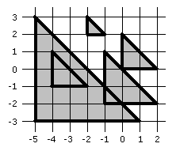
5  -5 -3 6  -1 -2 3  0 0 2  -2 2 1  -4 -1 2 | 24.5

